AZ 104 - Lab 05 - Implement Intersite Connectivity – Velibor Stanisic

Lab scenario
Contoso has its datacenters in Boston, New York, and Seattle offices connected via a mesh wide-area network links, with full connectivity between them. You need to implement a lab environment that will reflect the topology of the Contoso’s on-premises networks and verify its functionality.

Architecture diagram

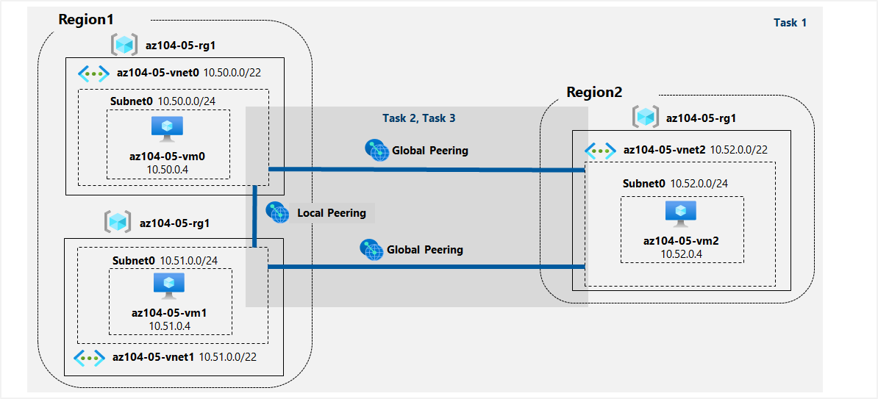

Task 1: Provision the lab environment
In this task, you will deploy three virtual machines, each into a separate virtual network, with two of them in the same Azure region and the third one in another Azure region.

4. In the toolbar of the Cloud Shell pane, click the Upload/Download files icon, in the drop-down menu, click Upload and upload the files \Allfiles\Labs\05\az104-05-vnetvm-loop-template.json and \Allfiles\Labs\05\az104-05-vnetvm-loop-parameters.json into the Cloud Shell home directory.
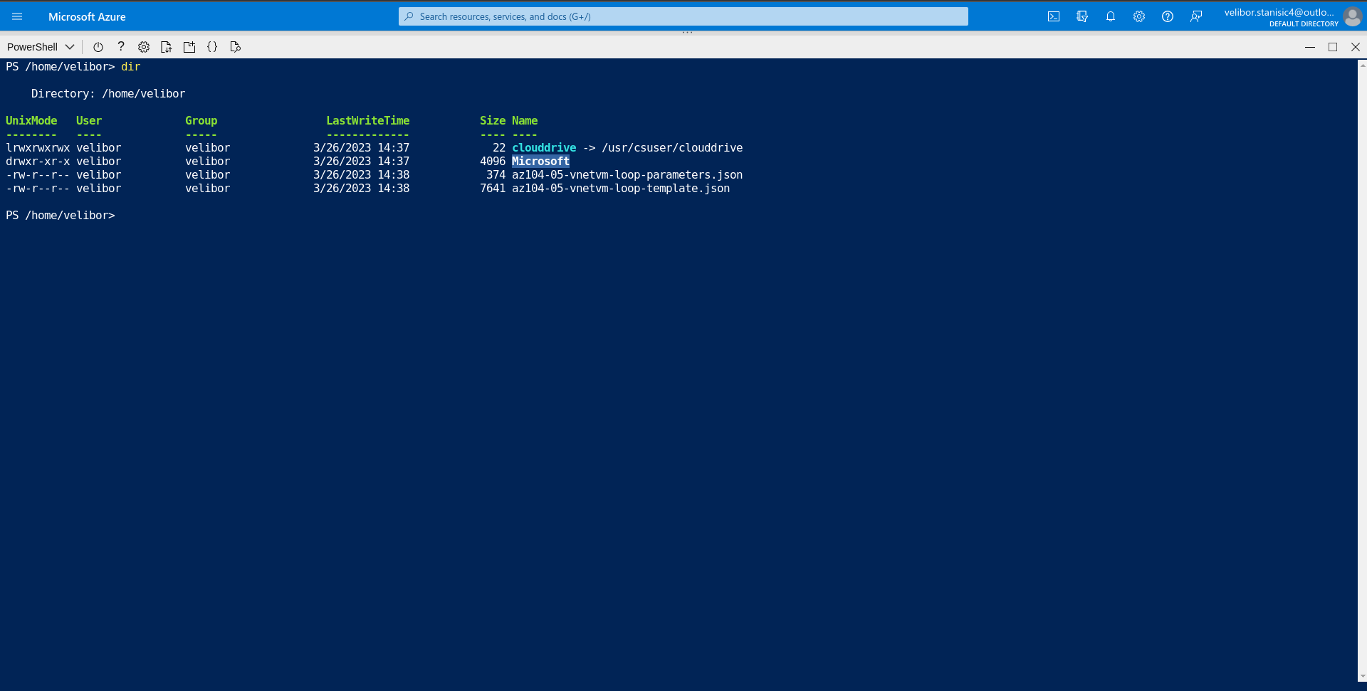

6. From the Cloud Shell pane, run the following to create the resource group that will be hosting the lab environment. The first two virtual networks and a pair of virtual machines will be deployed in [Azure_region_1]. The third virtual network and the third virtual machine will be deployed in the same resource group but another [Azure_region_2]. (replace the [Azure_region_1] and [Azure_region_2] placeholder, including the square brackets, with the names of two different Azure regions where you intend to deploy these Azure virtual machines. An example is $location1 = ‘eastus’. You can use Get-AzLocation to list all locations.):
$location1 = 'eastus'
$location2 = 'westus'
$rgName = 'az104-05-rg1'
New-AzResourceGroup -Name $rgName -Location $location1
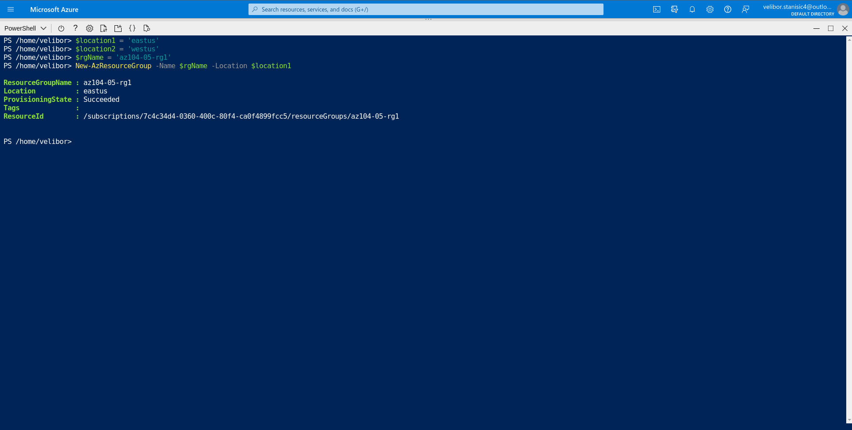

7. From the Cloud Shell pane, run the following to create the three virtual networks and deploy virtual machines into them by using the template and parameter files you uploaded:
New-AzResourceGroupDeployment `
-ResourceGroupName $rgName `
-TemplateFile $HOME/az104-05-vnetvm-loop-template.json `
-TemplateParameterFile $HOME/az104-05-vnetvm-loop-parameters.json `
-location1 $location1 `
-location2 $location2

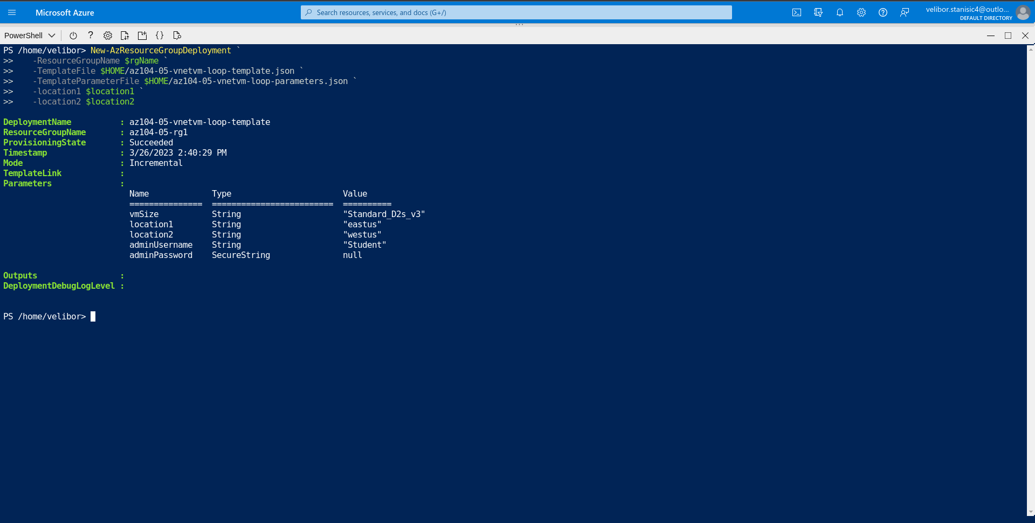
Task 2: Configure local and global virtual network peering
In this task, you will configure local and global peering between the virtual networks you deployed in the previous tasks.

2. Review the virtual networks you created in the previous task and verify that the first two are located in the same Azure region and the third one in a different Azure region.
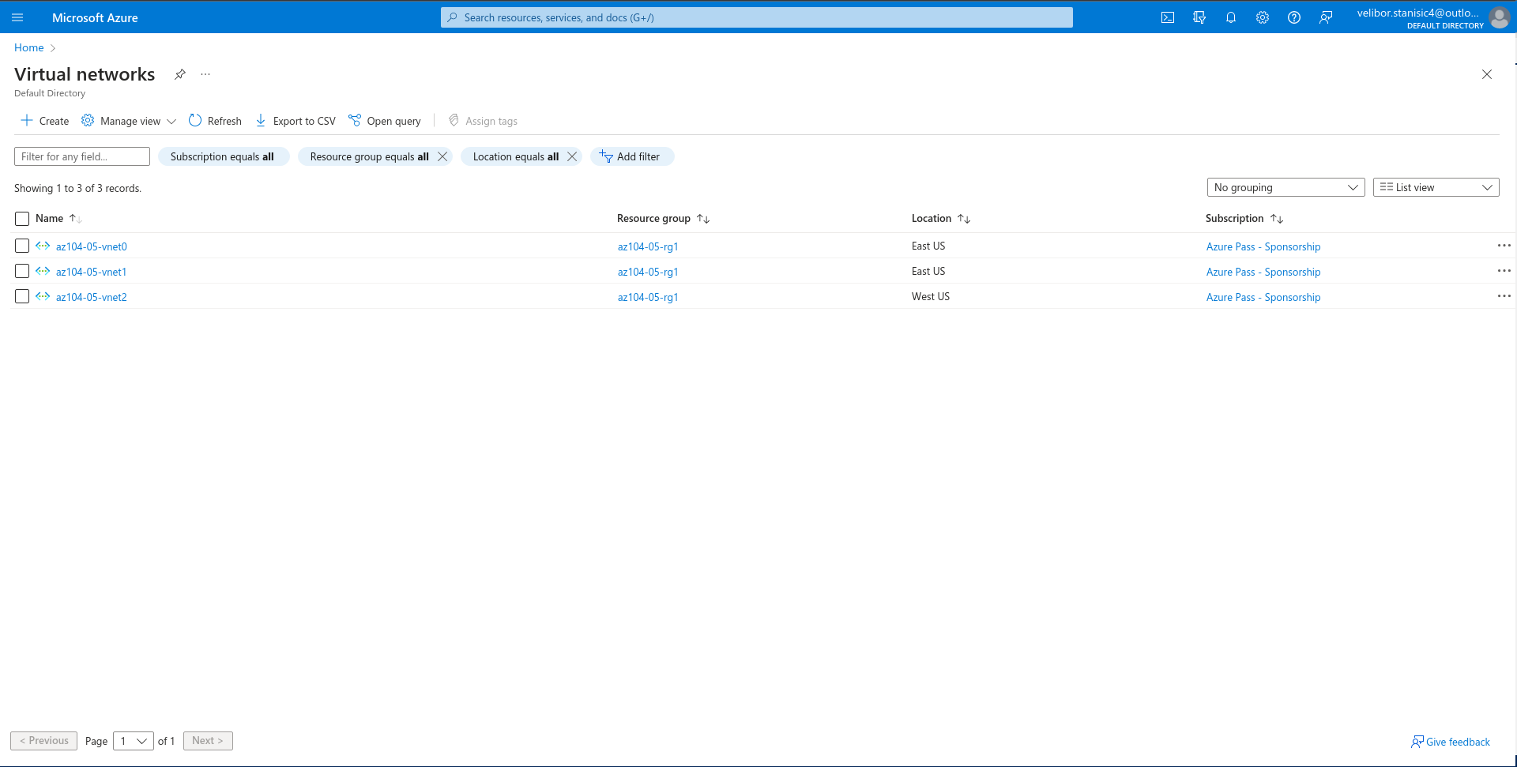

4. On the az104-05-vnet0 virtual network blade, in the Settings section, click Peerings and then click + Add.
5. Add a peering with the following settings (leave others with their default values) and click Add:
6. On the az104-05-vnet0 virtual network blade, in the Settings section, click Peerings and then click + Add.
7. Add a peering with the following settings (leave others with their default values) and click Add:
9. On the az104-05-vnet1 virtual network blade, in the Settings section, click Peerings and then click + Add.
10. Add a peering with the following settings (leave others with their default values) and click Add:
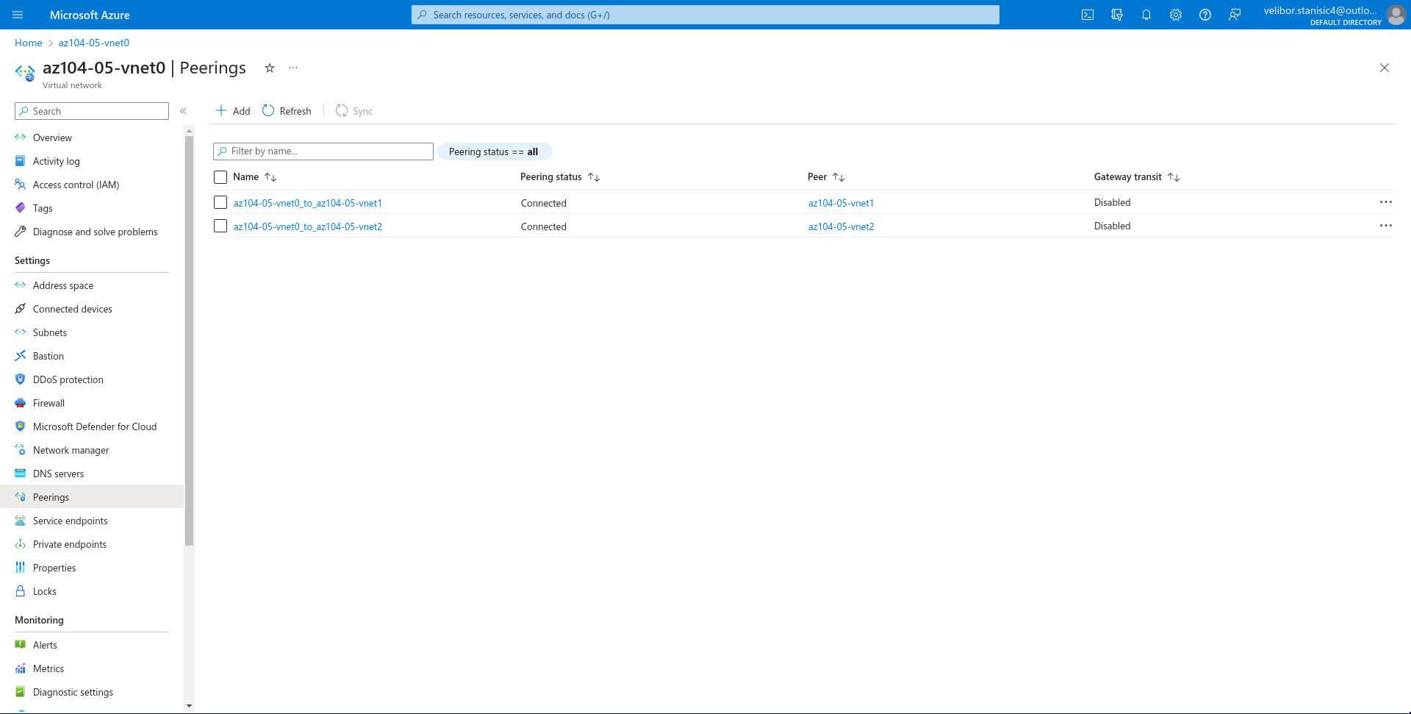

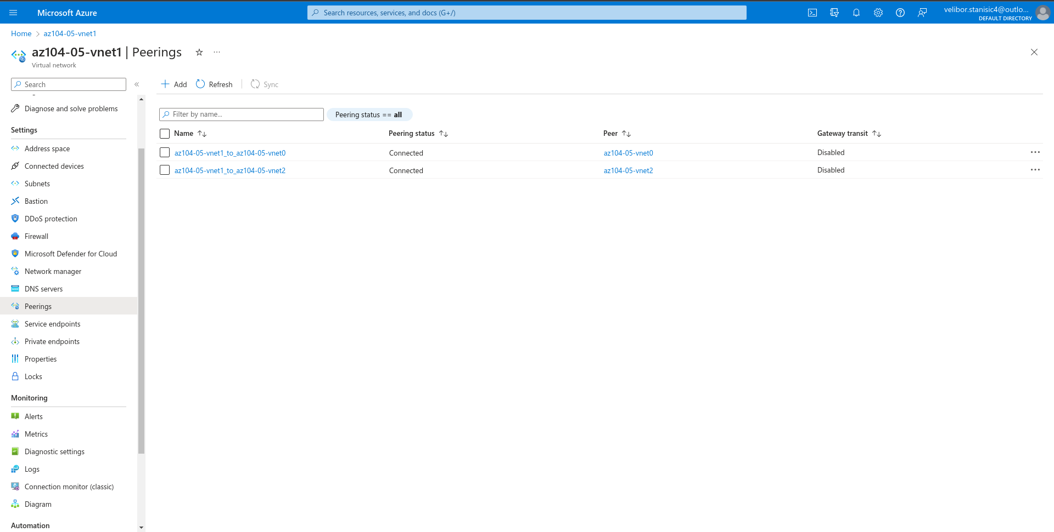

Task 3: Test intersite connectivity
In this task, you will test connectivity between virtual machines on the three virtual networks that you connected via local and global peering in the previous task.

6. In the Windows PowerShell console window, run the following to test connectivity toaz104-05-vm1 (which has the private IP address of 10.51.0.4) over TCP port 3389:

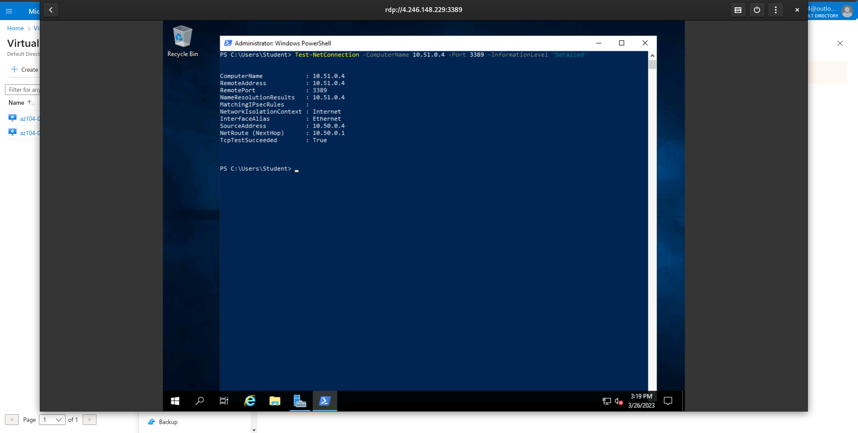

8.In the Windows PowerShell console window, run the following to test connectivity to az104-05-vm2 (which has the private IP address of 10.52.0.4):
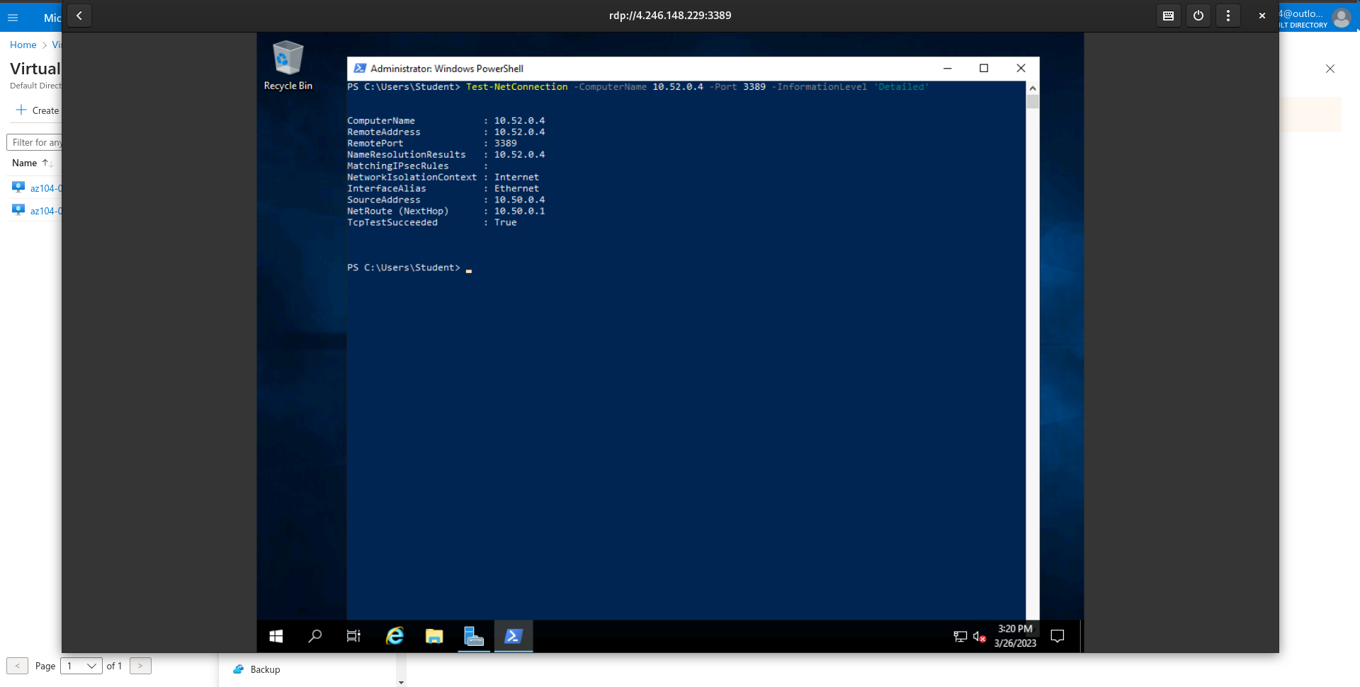

14. In the Windows PowerShell console window, run the following to test connectivity to az104-05-vm2 (which has the private IP address of 10.52.0.4) over TCP port 3389:
